

**Mawlana Bhashani Science and Technology University**

**Lab-Report**

Report No:07

Course code: ICT-3110

Course title: Operating System Lab

Date of Performance:

Date of Submission:

**Submitted by Submitted To**

Nazrul Islam

Assistant Professor

Dept. of ICT

MBSTU.

Name: Azharul Islam

ID:IT-18052

3rd year 1st semester

Session: 2017-2018

Dept. of ICT

MBSTU.

***Experiment No:07***

***Experiment Name:*** Implementation of FCFS Scheduling Algorithm.

**Theory:**

First Come First Serve (FCFS) is an operating system scheduling algorithm that automatically executes queued requests and processes in order of their arrival. It is the easiest and simplest CPU scheduling algorithm. In this type of algorithm, processes which requests the CPU first get the CPU allocation first. This is managed with a FIFO queue. The full form of FCFS is First Come First Serve.

As the process enters the ready queue, its PCB (Process Control Block) is linked with the tail of the queue and, when the CPU becomes free, it should be assigned to the process at the beginning of the queue.

• It supports non-preemptive and pre-emptive scheduling algorithm.

• Jobs are always executed on a first-come, first-serve basis.

• It is easy to implement and use.

• This method is poor in performance, and the general wait time is quite high.

**Program Implementation:**

**#include<stdio.h>**

**int main()**

**{**

**int n,bt[20],wt[20],tat[20],avwt=0,avtat=0,i,j;**

**printf("Enter total number of processes(maximum 20):");**

**scanf("%d",&n);**

**printf("\nEnter Process Burst Time\n");**

**for(i=0;i<n;i++)**

**{**

**printf("Process[%d]:",i+1);**

**scanf("%d",&bt[i]);**

**}**

**wt[0]=0;**

**for(i=1;i<n;i++)**

**{**

**wt[i]=0;**

**for(j=0;j<i;j++)**

**wt[i]+=bt[j];**

**}**

**printf("\nProcess\t\tBurst Time\tWaiting Time\tTurnaround Time");**

**for(i=0;i<n;i++)**

**{**

**tat[i]=bt[i]+wt[i];**

**avwt+=wt[i];**

**avtat+=tat[i];**

**printf("\nProcess[%d]\t\t%d\t\t%d\t\t%d",i+1,bt[i],wt[i],tat[i]);**

**}**

**avwt/=i;**

**avtat/=i;**

**printf("\n\nAverage Waiting Time:%d",avwt);**

**printf("\nAverage Turnaround Time:%d",avtat);**

**return 0;**

**}**

**Output Sample:**

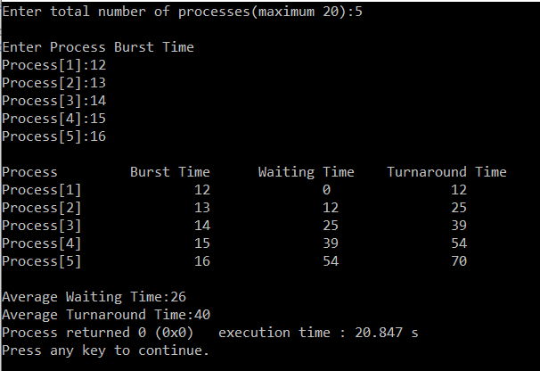

**Discussion:** The Lab is about FCFS (First Come First Serve). The lab helped us to understand the topic and implement in code. Now we could solve this kind of problems Further.